
Keeping friends of Marathon updated on our current projects
Current Scholarships
Madeline West Alysa Garcia Zoey Aguilar Elah Barlow Sadie Carter
College Grads
All of our college senior scholarship recipients - Jackson Barlow, Candace Aguilar and Campbell West - have graduated with Bachelor of Science degrees from their respective programs.
Moody M-Pact Grant
TMF sponsored MISD for the Moody Foundation M-Pact Grant, which MISD has been successfully awarded - $1.3M in funding over the next 3 years.
The first year began July 1, and the school has already started to work on converting the library to a new learning center, renovating the shop, and investing in educational equipment for our students.
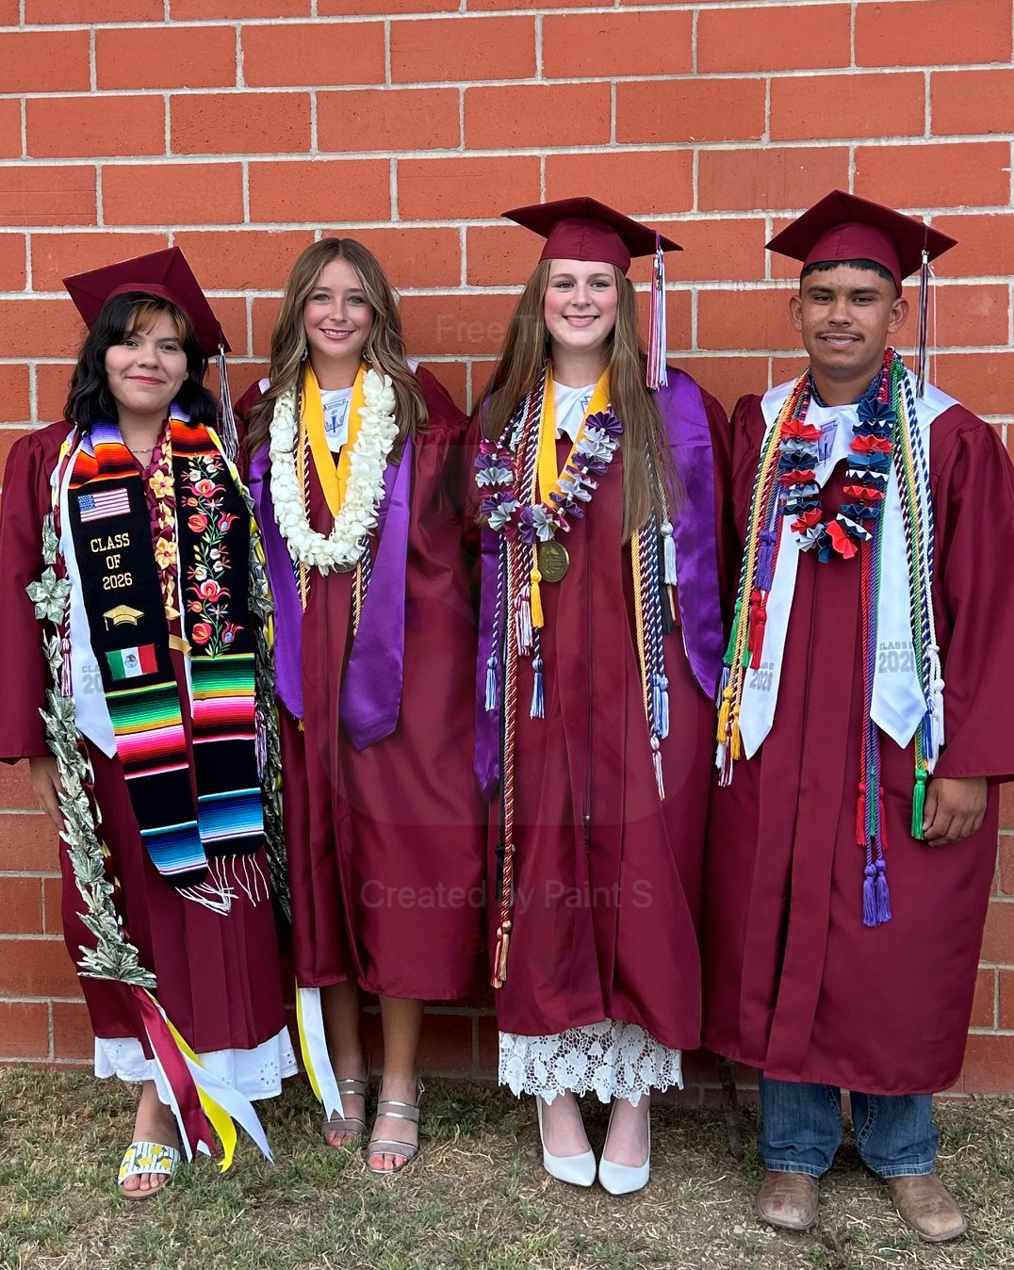

Cheers to the Graduates!
Congratulations to Elah Barlow, Sadie Carter, Marco Brionez and Nery Briones, our 2026 Marathon ISD graduates!
Elah and Sadie both received Marathon Foundation Scholarships. Elah will be attending Texas Tech and Sadie will be attending Texas A&M this fall. Marco has enlisted with the Marine Corps, and Nery has been awarded the Wrangler Promise Scholarship at Odessa College. We are so proud of all of their hard work!


Other happenings

- TMF’s matching fundraiser campaign for the Sunshine House warming drawer to be used for the senior Meals on Wheels program serving Marathon was a rousing success, reaching its $3000 goal from 13 members of the community which TMF matched in full!
- The May 2026 Marathon Golf Tournament fundraiser benefitting the Marathon Foundation and Marathon PTO Cultural Enrichment Program raised $12,235 from more than 60 donors and sponsors. A huge thanks to Phillip Moellering for organizing the tournament!
- TMF awarded the Marathon Volunteer Fire Department a grant to cover insurance for their vehicles to help make sure that they are able to roll at a moment’s notice
- Five MISD students participated in the Big Bend Stock Show and moved to sale, and were awarded $500 each by TMF. Annaliese West, who showed goats, also participated in the 4H Globe Program in Costa Rica this summer.
Find us on Instagram: themarathonfoundation
Find us online and donate: themarathonfoundation.org

Cultural Enrichment 2026
Once again this year, the Marathon Foundation was honored to help MISD students and their chaperones travel across the country, this time to Chicago. Ten students spent six days exploring the city, including the Art Institute of Chicago, the Griﬃn Museum of Science and Industry, an architectural cruise and interior walking tour, the Lyric Opera to see a Joﬀrey Ballet production, and a White Sox game. The students thoroughly enjoyed seeing the sights and making lasting memories during their time in Chigaco!

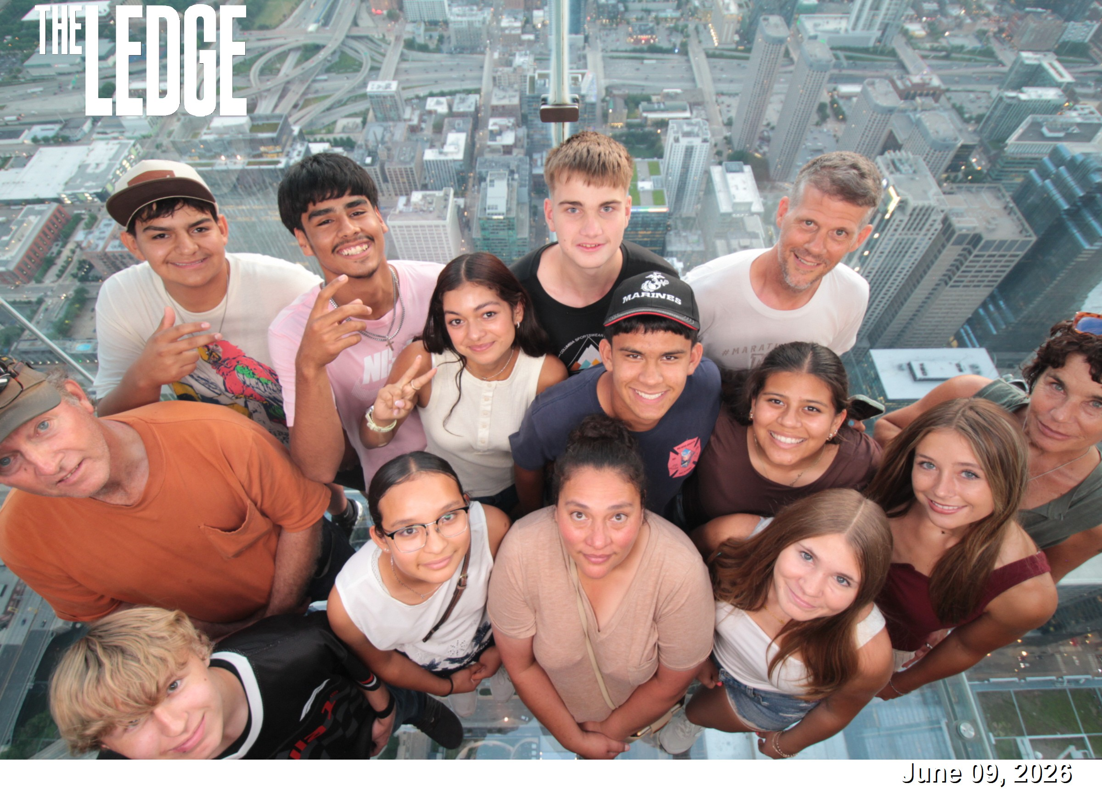

The Marathon Foundation is grateful for its supporters who understand the importance of aiding a small town’s educational and community services in ways which will allow the town to continue to prosper far into the future.
Thank you for all you have done for Marathon, and all that you may do in the future.

